**Experiment: 1**

**Aim:** Get a character from user and print tell that is it vowel or consonant.

**Software:** Dev C++

**Code:**

**#include<stdio.h>**

**int main()**

**{**

**char string[50];**

**int vovel=0,constant=0;**

**printf("ENter A String:-");**

**gets(string);**

**for(int i=0;i<50;i++)**

**{**

**if(string[i]=='A' || string[i]=='E' || string[i]=='I' || string[i]=='O' || string[i]=='U' || string[i]=='a' || string[i]=='e' || string[i]=='i' || string[i]=='o' || string[i]=='u')**

**{**

**vovel++;**

**}**

**else if(string[i] == NULL)**

**{**

**break;**

**}**

**else**

**{**

**constant++;**

**}**

**}**

**printf("There are %d Vovels and %d Constant",vovel,constant);**

**return 0;**

**Output:**

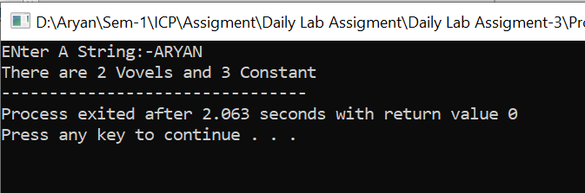

**Experiment: 2**

**Aim:** Write a program that take input of 5 subjects marks. If student get 40 or more then 40 then he is PASS in that subject  otherwise FAIL print the result for following condition.  
If student is pass in all  subjects  then declare PASS.  
Is student is fail in 1 or 2 subject then declare ATKT.  
If student is fail in more then 2 subject then declare FAIL.

**Software:** Dev C++

**Code:**

**#include<stdio.h>**

**int main()**

**{**

**int marks,fail=0;**

**for(int i=1;i<=5;i++)**

**{**

**printf("Enter The Marks-%d:-",i);**

**scanf("%d",&marks);**

**if(marks<40)**

**{**

**fail++;**

**}**

**}**

**if(fail==0)**

**{**

**printf("PASS");**

**}**

**else if(fail==1 || fail==2)**

**{**

**printf("ATKT");**

**}**

**else**

**{**

**printf("FAIL");**

**}**

**return 0;**

**}**

**Output:**

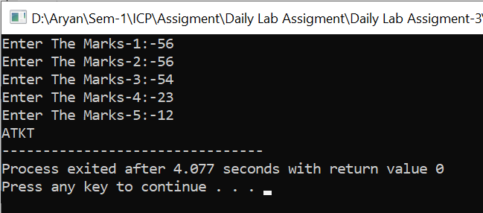

**Experiment: 3**

**Aim:** Write a program that performs the sum of given numbers until user says no using Go-To statement.

**Software:** Dev C++

**Code:-**

**#include<stdio.h>**

**int main()**

**{**

**int sum=0,n;**

**printf("Press 0 To Exit\n");**

**for(int i=1;i<=100;i++)**

**{**

**printf("Enter The Number:-");**

**scanf("%d",&n);**

**if(n==0)**

**{**

**printf("PROGRAMM ENDS\n");**

**break;**

**}**

**else**

**{**

**sum=sum+n;**

**}**

**}**

**printf("The Addition Of All Numbers That You Entered Is %d",sum);**

**}**

**Output:**

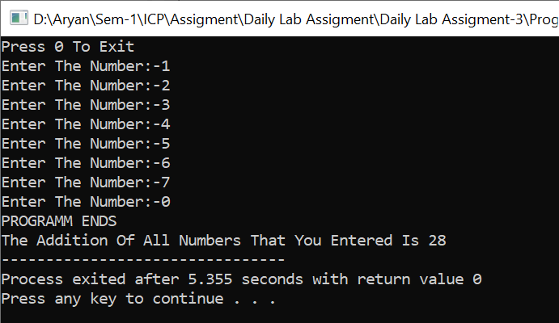

**Experiment: 4**

**Aim:**  Except one no from user and find if it is Armstrong or not.

**Software:** Dev C++

**Code:-**

**#include<stdio.h>**

**#include<math.h>**

**int main(void)**

**{**

**int num,temp,i=0,ans,j,new_num=0,ans1=0;**

**float rev_num=0;**

**printf("Enter A Number:-");**

**scanf("%d",&num);**

**temp=num;**

**new_num = num;**

**while(num!= 0)**

**{**

**ans=num%10;**

**num=num/10;**

**i++;**

**}**

**for(j=1;j<=i;j++)**

**{**

**ans=0;**

**ans=temp%10;**

**temp=temp/10;**

**ans1= pow(ans,i);**

**rev_num = rev_num + ans1;**

**}**

**if(new_num == rev_num)**

**{**

**printf("%d Is An Armstrong Number",new_num);**

**}**

**else**

**{**

**printf("%d Is Not An Armstrong Number",new_num);**

**}**

**return 0;**

**}**

**Output:-**

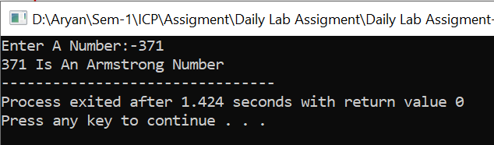

**Experiment: 5**

**Aim:-**  Write a program to count the number of even numbers between 1 and 20

**Software:-** Dev C++

**Code:-**

**#include<stdio.h>**

**int main()**

**{**

**int num=0;**

**for(int i=1;i<=20;i++)**

**{**

**if(i%2==0)**

**{**

**num++;**

**}**

**}**

**printf("There Are %d Even Numbers in [1,20]",num);**

**return 0;**

**}Output:-**

